UNIT IV
NETWORK TOPOLOGY
- Define the following with respect to graph theory
- i) Tree ii) Link iii) Cutest iv)Tie set v) Twig
- Explain formation of Tie set and fundamental Tie set matrix with an example
- Explain formation of Cut set and fundamental Cut set matrix with an example
- What is complete incidence matrix? How is it reduced to incidence matrix? Explain with suitable examples.
- Explain the concept of Duality and What are the steps involved to obtain dual network.
- For the network shown in Fig. draw the oriented graph. Also draw the no. of possible trees and selecting any one tree Write the cut set schedule.
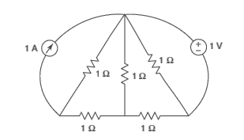

- For this network shown in Fig., write down the tie set matrix and obtain the network equilibrium equation in matrix form using KVL. Calculate the loop currents and branch currents. 